Question 3

a) code:

% Simulate two return series

% simulate Moving average, MA(1)

modelMA01 = arima('constant', 0.1, 'MA', 0.85, 'variance', 0.15);

rng('default')

MA01=simulate(modelMA01,1000);

figure;

subplot(1,1,2)

plot(MA01)

title('Simulated MA(1)')

% simulate Moving average, MA(2)

modelMA02 = arima('constant',0.3,'MA',{0.85,0.1},'variance',0.15);

rng('default')

MA02=simulate(modelMA02,1000);

subplot(2,1,2)

plot(MA02)

title('Simulated MA(2)')

The plot:

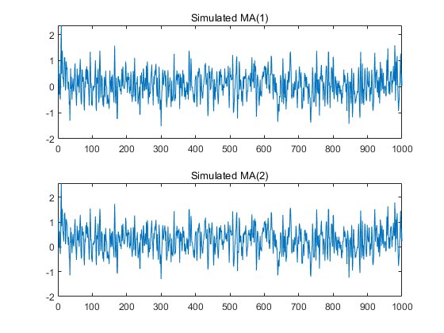

b) Code:

% Autocorrelation and partial autocorrelation

figure;

subplot(2, 1, 1);

autocorr(MA01);

title('ACF for MA(1)');

subplot(2, 1, 2);

parcorr(MA01);

title('PACF for MA(1)');

figure;

subplot(2, 1, 1);

autocorr(MA02);

title('ACF for MA(2)');

subplot(2, 1, 2);

parcorr(MA02);

title('PACF for MA(2)');

The plot:

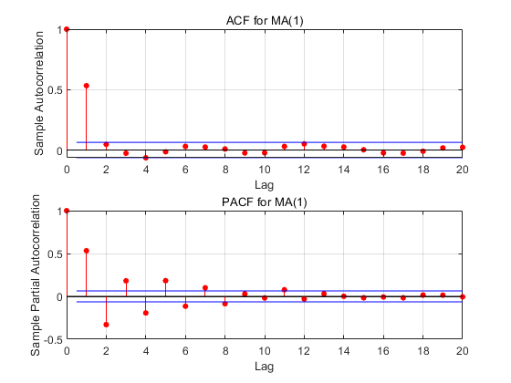

Clearly, since the ACF cuts off at lag 1, and PACF decreases gradually, we can think of this series as a MA(1) series.

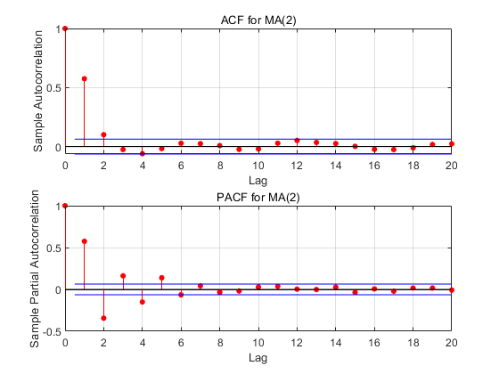

Clearly, since the ACF cuts off at lag 2, and PACF decreases gradually, we can think of this series as a MA(2) series.

c) Code:

% Estimate model parameters: Model 1

model01 = arima('MAlags', 1);

ESTmodel01 = estimate(model01, MA01);

% Check stationarity

[res01,v01,logl01]=infer(ESTmodel01,MA01);

stdres01=res01./sqrt(v01);

% for return series - serial correlation and ARCH-effect check

disp('MODEL 1 diagnostics')

[h, p, Qstat, Critical]=lbqtest(stdres01,'Lags',[5 10 15])

[h, p, Qstat, Critical]=archtest(stdres01,'Lags',[5 10 15])

The derived model is :

ARIMA(0,0,1) Model (Gaussian Distribution):

Value StandardError TStatistic PValue

________ _____________ __________ ___________

Constant 0.075072 0.022447 3.3444 0.00082469

MA{1} 0.83768 0.017229 48.619 0

Variance 0.14942 0.0062646 23.852 9.6433e-126

After standardize the residuals, I used both lbq test and ARCH test to check the stationarity, the null hypothesis cannot be rejected under 95% confidence level in all cases except that when lags=5, and use ARCH test. In that case, we reject the null hypothesis.

d) Code:

% Estimate model parameters: Model 2

model02 = arima('MAlags', 2);

ESTmodel02 = estimate(model02, MA02);

% Check stationarity

[res02,v02,logl02]=infer(ESTmodel02,MA02);

stdres02=res02./sqrt(v02);

% for return series - serial correlation and ARCH-effect check

disp('MODEL 2 diagnostics')

[h, p, Qstat, Critical]=lbqtest(stdres02,'Lags',[5 10 15])

[h, p, Qstat, Critical]=archtest(stdres02,'Lags',[5 10 15])

The derived model is :

ARIMA(0,0,2) Model (Gaussian Distribution):

Value StandardError TStatistic PValue

_______ _____________ __________ ___________

Constant 0.27592 0.018332 15.051 3.3854e-51

MA{2} 0.11663 0.031648 3.6851 0.00022857

Variance 0.26722 0.011092 24.091 3.1151e-128

After standardize the residuals, I used both lbq test and ARCH test to check the stationarity, the null hypothesis is rejected under 95% confidence level in all cases. Thus the model is not stationary.

Question 4

a) 见拍照手算结果，Q(5) = 13.0175, critical value = 11.070, since Q(5) > 11.070, we reject the null hypothesis, so there is significant autocorrelation at lags up to 5. After comparing with built-in function lbqtest, we get the same results.

Code:

load Data_FXRates.mat

price = DataTable.JPY;

ret = price2ret(price);

%ACF for JPY return

ACFret = autocorr(ret, 5)

%Ljung-Box Qtest for JPY return

[h,p,Qstat,Critical] = lbqtest(ret,'lags',5 )

% The results are the same.

b) Code:

% Construct AR(1) - GARCH(1, 1) nromal

modelA = arima('ARlags',1,'Variance',garch(1,1))

ESTmodelA = estimate(modelA, ret)

The estimated models are:

ARIMA(1,0,0) Model (Gaussian Distribution):

Value StandardError TStatistic PValue

___________ _____________ __________ ________

Constant -7.0977e-05 9.2366e-05 -0.76844 0.44223

AR{1} 0.035069 0.015265 2.2973 0.021602

GARCH(1,1) Conditional Variance Model (Gaussian Distribution):

Value StandardError TStatistic PValue

__________ _____________ __________ __________

Constant 1.4092e-06 3.156e-07 4.4653 7.9967e-06

GARCH{1} 0.91067 0.0049246 184.92 0

ARCH{1} 0.05975 0.0035274 16.939 2.3174e-64

We can observe that the P values are all below 0.05 except the constant term in the mean equation, which means all parameters are significantly different from zero except the constant term in the mean equation. So this model fits the data quite well.

c) Code:

% Construct AR(1)-GARCH(1,1) student-t(dof)

modelB = arima('ARlags',1,'Variance',garch(1,1),'distribution','t')

ESTmodelB = estimate(modelB, ret)

The estimated models are:

ARIMA(1,0,0) Model (t Distribution):

Value StandardError TStatistic PValue

__________ _____________ __________ __________

Constant 0.00014854 7.987e-05 1.8598 0.062916

AR{1} -0.0037342 0.013894 -0.26876 0.78811

DoF 4.0832 0.29992 13.614 3.2937e-42

GARCH(1,1) Conditional Variance Model (t Distribution):

Value StandardError TStatistic PValue

__________ _____________ __________ __________

Constant 9.5615e-07 3.9395e-07 2.4271 0.015221

GARCH{1} 0.92275 0.0084616 109.05 0

ARCH{1} 0.065757 0.0081673 8.0512 8.1959e-16

DoF 4.0832 0.29992 13.614 3.2937e-42

We can observe from the P values that the AR(1) term is 0.78811, which is very large, much larger than the threshold 0.05, so this term is not significantly different from zero. Meanwhile the constant term is 0.0629, also a bit larger than 0.05. So This model does not fit the data that well like the first model does.